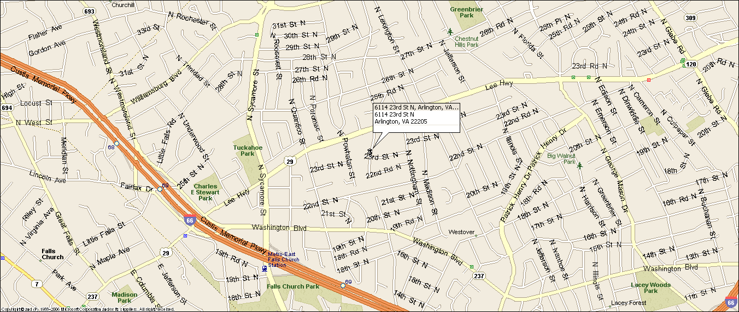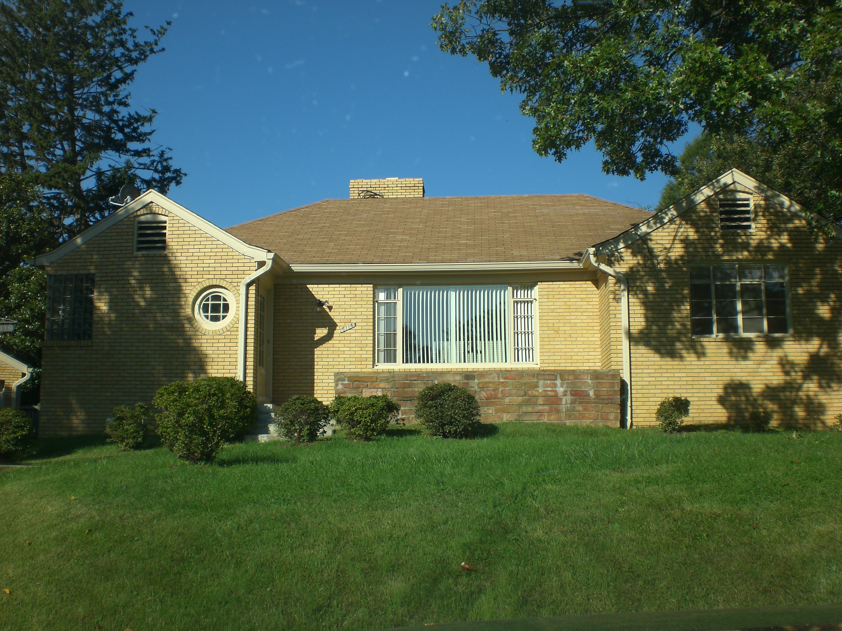
6114 N. 23rd Street Arlington, VA 22205
North Arlington Classic SFH
Great location: Walk to EFC Metro & Westover Village & Library, Close to DC (6 miles), Tyson’s Corner (6 miles), I-66, Rt. 29
- Five bedrooms, four full baths.
- Central a/c, natural gas heat & hot water.
- Large 2 car detached garage
- Large landscaped yard, rear patio, great back yard.
- Original hardwood floors thru out upper level, new lower level flooring & paint.
- Established quiet neighborhood, cull de sac
- Excellent Schools: Tuckahoe Elementary, Swanson MS, & Yorktown HS
- Lease terms: 1 year minimum, no smoking, no use of fire place.

RENT: $4,500.00 / month + utilities, contact Lyndsay Saffer 703-906-3082
Email: safferlyndsay@gmail.com

